**Practical no. 7**

**FS19CO042**

**Aim:** Write a Python program to demonstrate the use of if and if else.

**Problem statements:**

1. Check if given number is even or odd.
2. Display grade of student depending on percentage.  
   percentage>=90: Excellent   
   percentage>=80 and <90: First class   
   percentage>=60 and <80: Second class   
   percentage>=40 and <60: Pass class   
   percentage < 40: Fail

**Theory:**

* **If statement**An if statement is used to execute a statement/set of statements only when the specified condition is satisfied i.e. expression resolves TRUE, otherwise program continues unaffected.

**Syntax:**

if expression:

statementset

**For example,**

if n==5:

print(“No. is 5”) # This statement gets executed only if n=5

* **If….else statement**

An If…else statement is combination of If with else. Here, statement1 occurs only if expression resolves TRUE otherwise statement2 occurs.

Here, either of the statement occurs.

**Syntax:**

if expression:

statementset1

else:

statementset2

**For example,**

if n==5:

print(“No. is 5”) # This statement gets executed only if n=5  
 else:

print(“No. is not 5”) # If no. is not equal to 5, this statement occurs

* **Elif statement**

The **elif** statement allows checking multiple expressions for TRUE and execute a block of code as soon as one of the conditions evaluates to TRUE.

Similar to the **else**, the **elif** statement is optional. One can put as many elif as possible after if.

Syntax:

if expression:

statementset1

elif expression2:

statementset2

elif expression3:

statementset3

else:

statementset4

For example,

If n==2:

print(“n is 2!”)

elif n==3:

print(“n is 3!”)

elif n==4:

print(“n is 4!”)

else:

print(“Don’t know what it is “);

**Code:**

1. **Check if given number is even or odd.**

# Check if given number is even or odd.

number = int(input("Enter a number: "))

if number%2 == 0:

print("Number entered,", number, "is an even nunber.")

else:

print("Number entered,", number, "is an odd nunber.")

Output:

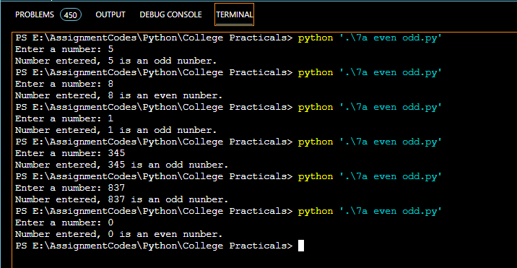

1. **Display grade of student depending on percentage.  
   percentage>=90: Excellent   
   percentage>=80 and <90: First class   
   percentage>=60 and <80: Second class   
   percentage>=40 and <60: Pass class   
   percentage < 40: Fail**

# Display grade of student depending on percentage

percentage = int(input("Enter student's percentage: "))

print("Your grade: ",end="")

if percentage >= 90:

print("Excellent")

elif percentage >= 80:

print("First class")

elif percentage >= 60:

print("Second class")

elif percentage >= 40:

print("Pass class")

else:

print ("Failed")

Output:

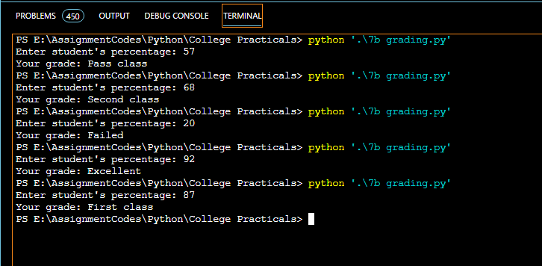

Conclusion: Thus, we understood and implemented If, elif and if-else while implementing given problem statements.

**Practical no. 8**

**FS19CO042**

**Aim:** Develop a user defined Python function to demonstrate the use of parameterized function & value return functions.

**Problem statements:**

1. Check if a number is prime or not.
2. Write a menu driven program, using user defined functions to find the area of rectangle, square, circle and triangle by accepting suitable input parameters from user.

**Theory:**

* **Functions in python**

A function is a reusable block of code which only runs when it is called. It can be called as many times as possible without writing same code again and again.  
Example,

# Defining a function  
def sayHello():

print(“Hello Pythoneeers !!”)

# Calling a function

sayHello()

* **Parameterized functions**

Functions can be given different arguments which take value when they’re called and perform operations as per the value specified each time.

Example

def sayHello(name):

Print(“Hello pythoneer “+name)

sayHello(“Jonas”)

sayHello(“Mark”)

* **Return functions**

A return statement ends execution of the function call and returns the result obtained by performing certain operations.

Example,

def add(a,b):

return a+b

print(add(5,7)) # 12print(add(32,3)) # 35